Introduction to How Rainbows Work

Rainbows are one of the most beautiful spectacles nature has to offer -- so beautiful, in fact, that they've inspired countless fairy tales, songs and legends. It's a good bet that most of the artists behind these tales were totally mystified by the rainbow phenomenon -- just like most people are today. But the science of rainbows is really very simple. It's just basic optics!

Have you ever wondered how the colors of a rainbow end up in seemingly perfect bands?

Light Bends

The fundamental process at work in a rainbow is refraction -- the "bending" of light.

Light bends -- or more accurately, changes directions -- when it travels from one medium to another. This happens because light travels at different speeds in different mediums.

To understand why light bends, imagine you're pushing a shopping cart across a parking lot. The parking lot is one "medium" for the shopping cart. If you're exerting a constant force, the cart's speed depends on the medium it's traveling through -- in this case, the parking lot's paved surface. What happens when you push the shopping cart out of the parking lot, onto a grassy area? The grass is a different "medium" for the shopping cart. If you push the cart straight onto the grass, the cart will simply slow down. The grass medium offers more resistance, so it takes more energy to move the shopping cart. But when you push the cart onto the grass at an angle, something else happens. If the right wheel hits the grass first, the right wheel will slow down while the left wheel is still on the pavement. Because the left wheel is briefly moving more quickly than the right wheel, the shopping cart will turn to the right as it moves onto the grass. If you move at an angle from a grassy area to a paved area, one wheel will speed up before the other and the cart will turn.

Similarly, a beam of light turns when it enters a glass prism. This is a simplification, but think about it this way: One side of the light wave slows down before the other, so the beam turns at the boundary between the air and the glass (some of the light actually reflects off the prism surface, but most passes through). The light turns again when it exits the prism, because one side of it speeds up before the other.
In addition to bending light as a whole, a prism separates white light into its component colors. Different colors of light have different frequencies, which causes them to travel at different speeds when they move through matter.

A color that travels more slowly in glass will bend more sharply when it passes from air to glass, because the speed difference is more severe. A color that moves more quickly in glass won't slow down as much, so it will bend less sharply. In this way, the colors that make up white light are separated according to frequency when they pass through glass. If the glass bends the light twice, as in a prism, you can see the separated colors more easily. This is called dispersion.
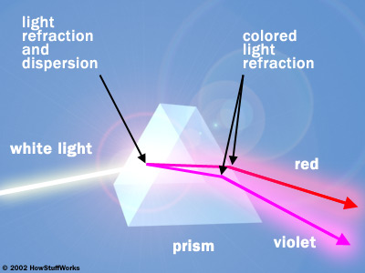
A prism separates white light into its component colors. For simplicity's sake, this diagram shows only red and violet, which are on opposite ends of the spectrum.

Drops of rainwater can refract and disperse light in the same basic way as a prism. In the right conditions, this refraction forms rainbows. In the next section, we'll find out how this happens.

Making a Rainbow
An individual raindrop has a different shape and consistency than a glass prism, but it affects light in a similar way. When white sunlight hits a collection of raindrops at a fairly low angle, you can see the component colors red, orange, yellow, green, blue, indigo and violet -- a rainbow. For simplicity's sake, we'll only look at red and violet, the colors of light on the ends of the visible light spectrum.
The diagram below shows what happens when the sunlight hits one individual raindrop.
When the white light passes from air into the drop of water, the component colors of light slow down to different speeds depending on their frequency. The violet light bends at a relatively sharp angle when it enters the raindrop. At the right-hand side of the drop, some of the light passes back out into the air, and the rest is reflected backward. Some of the reflected light passes out of the left side of the drop, bending as it moves into the air again. In this way, each individual raindrop disperses white sunlight into its component colors. So why do we see wide bands of color, as if different rainy areas were dispersing a different single color? Because we only see one color from each raindrop. You can see how this works in the diagram below.
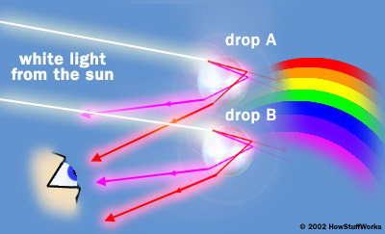

When raindrop A disperses light, only the red light exits at the correct angle to travel to the observer's eyes. The other colored beams exit at a lower angle, so the observer doesn't see them. The sunlight will hit all the surrounding raindrops in the same way, so they will all bounce red light onto the observer.
Raindrop B is much lower in the sky, so it doesn't bounce red light to the observer. At its height, the violet light exits at the correct angle to travel to the observer's eye. All the drops surrounding raindrop B bounce light in the same way. The raindrops in between A and B all bounce different colors of light to the observer, so the observer sees the full color spectrum. If you were up above the rain, you would see the rainbow as a full circle, because the light would bounce back from all around you. On the ground, we see the arc of the rainbow that is visible above the horizon.
Sometimes you see a double rainbow -- a sharp rainbow with a fainter rainbow on top of it. The fainter rainbow is produced in the same way as the sharper rainbow, but instead of the light reflecting once inside the raindrop, it's reflected twice. As a result of this double reflection, the light exits the raindrop at a different angle, so we see it higher up. If you look carefully, you'll see that the colors in the second rainbow are in the reverse order of the primary rainbow.
And that's really all there is to rainbows. Light and water happen to combine in just the right way to paint a beautiful natural picture.

